(3 Point) Design and code a class named Box that holds information about a BOx and class named ColorBox which is derived from Box.

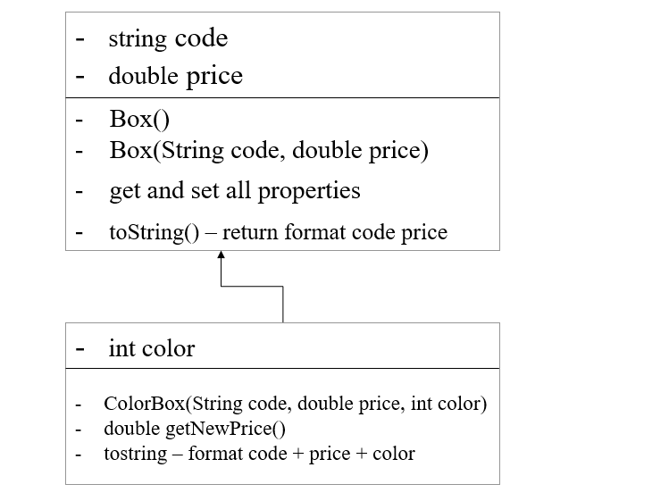

- getNewPrice():double – use to determine new price of box, new price = original price + tax, where:
    - tax = 10 percent out of original price if color > 100
    - Otherwise free tax.
Do not format the format the result.
The program output might look something like:

Correct output | Correct output
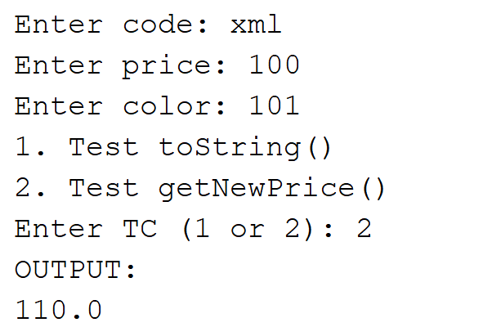 | 